Hi Students! These activities revise Mini Grammar (U3A), Reading (U3A/B). Have fun!
Grammar tip:

So + adjective
Example: You are so beautiful

So + adverb
Example: You dance so beautifully today.

Such + noun phrase
Example: You are such a beautiful lady.
UPPER-INTERMEDIATE II - EXTRA ACTIVITIES
Teacher: Milena Alonso – mpoalonso@uem.br
NAME:_________________________________________________ GROUP:__________________
1) Complete the text with so / such.

Finland is (1)_______ a nice place to go on winter holidays. The winter there is (2)_______ mild and welcoming! You can do snowboarding, skating, skiing or any other winter sport, there are (3)_______ many possibilities. We found (4)_______ a lovely hotel, and it was (5)_______ a short walk to the skiing slope. Well, winter season in Finland is not (6)_______ cheap as we expected, but we had (7)_______ a great time there. It is (8)_______ tempting to come there every winter, again and again.

2) Write so / such in the dialogue situations.

- Mike: Ann, you are ____ late today, is everything o.k.?
Ann: I’m fine. I’m ____ sorry to make you wait on ____ a hot day.
- Luke: Brenda, why do you look ____ utterly surprised?
Brenda: I was told ____ an unexpected story today, Luke.
- Sophie: William, it is ____ a generous gift, thank you.
William: It is ____ a great feeling to see your joy.
- Dan: It is ____ a nice offer, Bill, but I’ve got plans for the weekend.
Bill: It is ____ upsetting!
- Sam: Oh, it is ____ an awkward situation, sorry, Lily.
Lily: Don’t be ____ sorry, it is nothing at all.
- David: Philip, sometimes you are ____ persuasive!
Philip: I just wanted your company ____ much today, David
- Chris: I’m ____ clumsy, sir! Can you be ____ kind to forgive me?
Seller: It will be ____ nice of you to help me with ____ a mess.
- Greg: Why do you always need to be ____ a cruel lady, Kate?
Kate: It is not ____ easy to be nice and hospitable when people around do ____ things as you do.

3) Match the pairs to form sentences.

- It was such a lovely  - We appreciate your  - I’m so glad to  - Why are you so sad if  - It was such a bad idea  - You are so young  - Albert was so close to  - How dare she say such  - The play was such a  - I’ve never heard such | - help so much!  - finding out the truth.  - great success!  - invite you all to our party.  - compared to your sister.  - picnic yesterday evening!  - a foolish idea from anyone.  - to bake green beans alone.  - an awful thing about me?  - you’ve done nothing wrong?

4) Rephrase the sentences to replace such with so and vice versa, depending on the context.

Example: It was so lonely there. -> It was such a lonely day there.

- You have such a big and comfortable house!
_______________________________________________
- Her Swiss watch is so unique and expensive.
_______________________________________________
- She had such a busy preparation for her wedding.
_______________________________________________
- Your room is so untidy and not cozy.
_______________________________________________
- It was such an obvious decision for you.
_______________________________________________

SO… THAT / SUCH A(N)… THAT

5) Join these pairs of sentences using ‘so…that’ or ‘such (a)….that’.

a) He was very lazy. He did nothing all day long.
_______________________________________________________________________________________
b) It is a very good story. I’ll never forget it.
_______________________________________________________________________________________
c) The light was bright. She had to cover her eyes.
_______________________________________________________________________________________
d) I have a very bad memory for faces. I might not know him again.
_______________________________________________________________________________________
e) The guests were very hungry. They could not wait for knives and forks.
_______________________________________________________________________________________
f) They faced many difficulties. They did not manage to climb the mountain.
_______________________________________________________________________________________
g) It was a difficult problem. No one could solve it.
_______________________________________________________________________________________

6) Match half from A with another half from B using ‘so…that’ o ‘such(a)…that’.
A B
1-I’ve heard terrible stories about that restaurant a-…in the end she poisoned him.
2-He worked very hard for his exams b-…even a child could have solved it.
3-He treated his wife badly c-…we left half way through.
4-The problem was very simple d-…he almost had a nervous breakdown.
5-It was a very boring film e-…nobody understood him.
6- He spoke very fast f-…I’m not going to eat there again.

1) _____________________________________________________________________________________
2) _____________________________________________________________________________________
3) _____________________________________________________________________________________
4) _____________________________________________________________________________________
5) _____________________________________________________________________________________
6) _____________________________________________________________________________________
READING COMPREHENSION
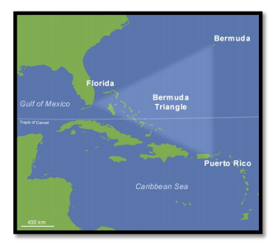
THE BERMUDA TRIANGLE – FLIGHT 19
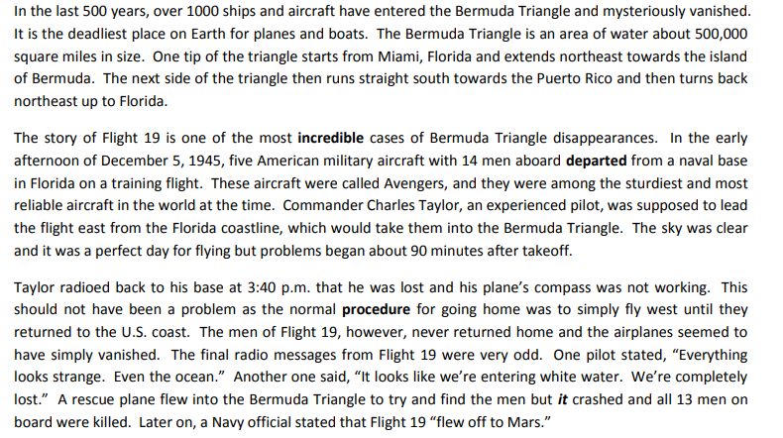
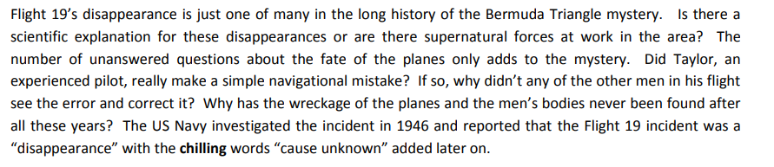

In order to listen to the story as you read, click on this link.

1. According to the article, how many ships and planes have disappeared in the Bermuda Triangle?
a) less than 1000
b) more than 1000
c) approximately 500
d) approximately 500,000

2. The word “incredible” in paragraph 2 is closest in meaning to:
a) believable
b) extraordinary
c) magnificent
d) extravagant

3. The word “departed” in paragraph 2 is closest in meaning to:
a) took off
b) took on
c) took out
d) took in

4. It can be inferred from paragraph 2 that
a) the commander of Flight 19 made a huge mistake
b) the type of aircraft was not suitable for this mission
c) it is quite obvious why the Flight 19 incident occurred
d) it is difficult to comprehend why the Flight 19 incident occurred

5. Paragraph 2 is about:
a) possible reasons why the Flight 19 incident occurred
b) an astonishing example of a Bermuda Triangle disappearance
c) an typical example of a Bermuda Triangle disappearance
d) the reasons why Flight 19 should have never departed from Florida

6. According to paragraph 3, what was the initial problem with the aircraft of Flight 19?
a) the controls in all of the aircraft stopped working
b) the pilot was having problems with the landing gear
c) one of the airplane’s compasses wasn’t functioning properly
d) one of the airplane’s engines wasn’t functioning properly

7. The word “procedure” in paragraph 3 is closest in meaning to:
a) routine
b) produce
c) property
d) tradition

8. The word “it” in paragraph 3 refers to:
a) Flight 19
b) the navy
c) the rescue plane
d) the U.S. coast

9. The word “chilling” in paragraph 4 is closest in meaning to:
a) exciting
b) cold
c) frightening
d) comforting

10. What can be determined about Flight 19 in paragraph 4?
a) the mystery has been solved
b) the cause of the incident was human error
c) the US Navy was responsible for their disappearance
d) the disappearance remains a mystery

11. It can be determined from paragraph 5 that
a) the US Navy’s investigation wasn’t thorough enough
b) the only explanation could be supernatural forces at work
c) there are many unanswered questions about the Flight 19 incident
d) many of the questions about the Flight 19 incident have been answered

ANSWER KEY
4) Rephrase the sentences to replace such with so and vice versa, depending on the context.

Example: It was so lonely there. -> It was such a lonely day there.

- You have such a big and comfortable house!
Your house is so big and comfortable!
- Her Swiss watch is so unique and expensive.
She has such a unique and expensive Swiss watch.
- She had such a busy preparation for her wedding.
Her preparation for the wedding was so busy.
- Your room is so untidy and not cozy.
You have such an untidy and not cozy room.
- It was such an obvious decision for you.
This decision was so obvious for you.
3) Match the pairs to form sentences.

- It was such a lovely  - We appreciate your  - I’m so glad to  - Why are you so sad if  - It was such a bad idea  - You are so young  - Albert was so close to  - How dare she say such  - The play was such a  - I’ve never heard such | - help so much!  - finding out the truth.  - great success!  - invite you all to our party.  - compared to your sister.  - picnic yesterday evening!  - a foolish idea from anyone.  - to bake green beans alone.  - an awful thing about me?  - you’ve done nothing wrong?

1 | 2 | 3 | 4 | 5 | 6 | 7 | 8 | 9 | 10
f | a | d | j | h | e | b | i | c | g

1) Complete the text with so / such.

Finland is (1)such a nice place to go on winter holidays. The winter there is (2)so mild and welcoming! You can do snowboarding, skating, skiing or any other winter sport, there are (3)so many possibilities. We found (4)such a lovely hotel, and it was (5)such a short walk to the skiing slope. Well, winter season in Finland is not (6)so cheap as we expected, but we had (7)such a great time there. It is (8)so tempting to come there every winter, again and again.
2) Write so / such in the dialogue situations.

- Mike: Ann, you are so late today, is everything o.k.?
Ann: I’m fine. I’m so sorry to make you wait on such a hot day.

- Luke: Brenda, why do you look so utterly surprised?
Brenda: I was told such an unexpected story today, Luke.

- Sophie: William, it is such a generous gift, thank you.
William: It is such a great feeling to see your joy.

- Dan: It is such a nice offer, Bill, but I’ve got plans for the weekend.
Bill: It is so upsetting!

- Sam: Oh, it is such an awkward situation, sorry, Lily.
Lily: Don’t be so sorry, it is nothing at all.

- David: Philip, sometimes you are so persuasive!
Philip: I just wanted your company so much today, David

- Chris: I’m so clumsy, sir! Can you be so kind to forgive me?
Seller: It will be so nice of you to help me with such a mess.

- Greg: Why do you always need to be such a cruel lady, Kate?
Kate: It is not so easy to be nice and hospitable when people around do such things like you do.

Exercise 5
a) He was so lazy that he did nothing all day long.
b) It is such a good story that I’ll never forget it.
c) The light was so bright that she had to cover her eyes.
d) I have such a bad memory for faces that I might not know him again.
e) The guests were so hungry that they could not wait for knives and forks.
f) They faced so many difficulties / such difficulties that they did not manage to climb the mountain.
g) It was such a difficult problem that no one could solve it.

Exercise 6
1) I’ve heard such terrible stories about that restaurant that I1m not going to eat there again.
2) He worked so hard for his exams that he almost had a nervous breakdown.
3) He treated his wife so badly that in the end he poisoned him.
4) The problem was so simple that even a child could solve it.
5) It was such a boring film that we left half way through.
6) He spoke so fast that nobody understood him.

READING COMPREHENSION KEY

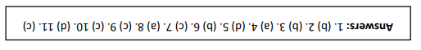

Please send a copy of the exercises to the teacher´s e-mail. Hope you enjoy guys!

