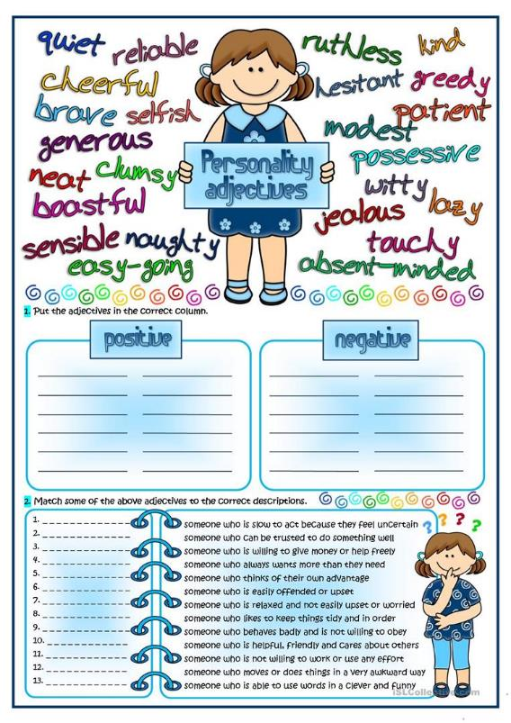

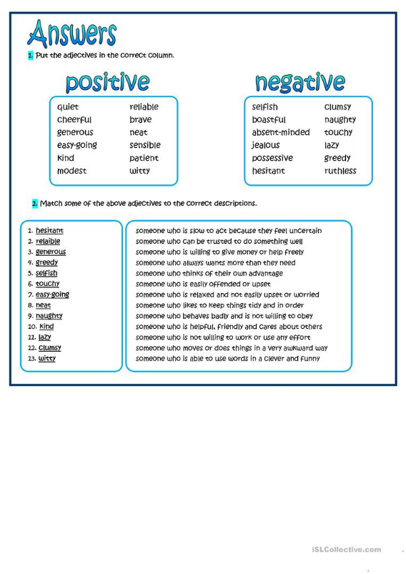

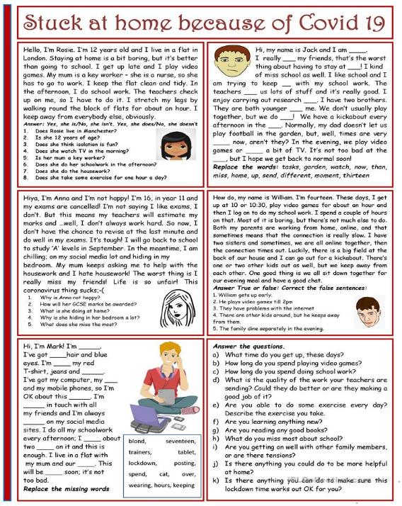

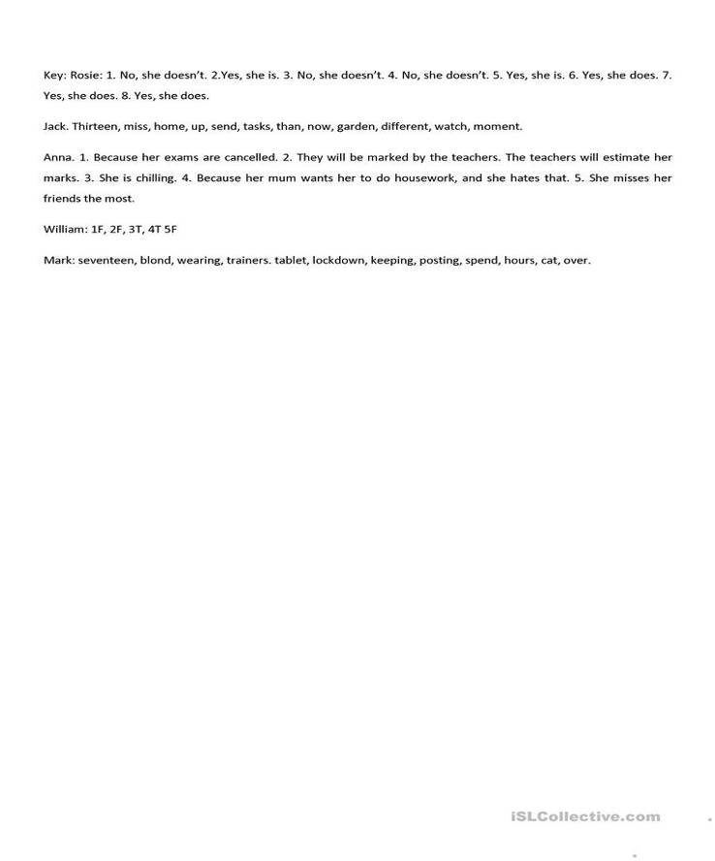

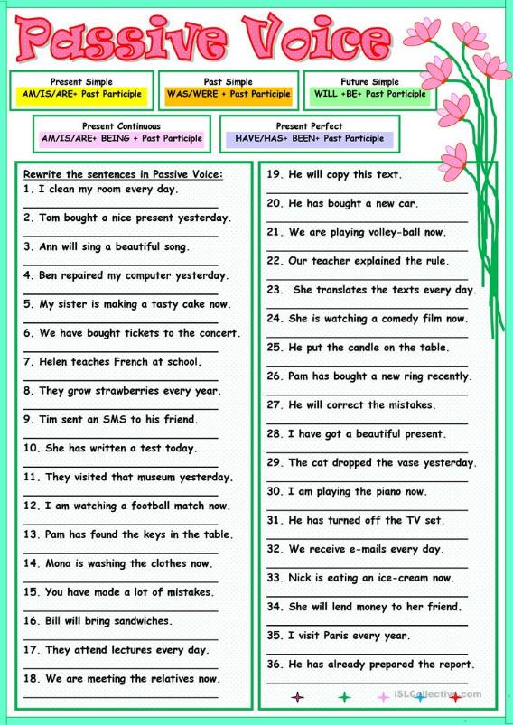

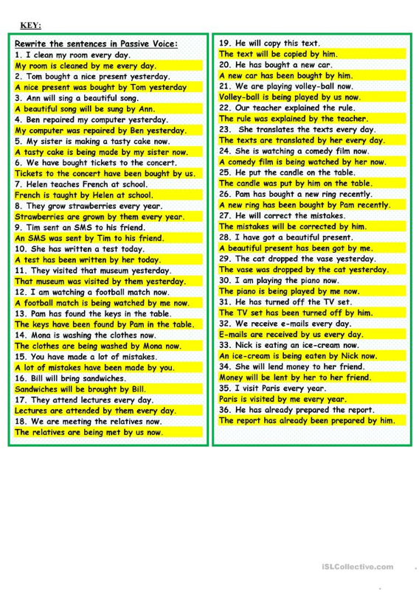

**First Conditional Exercises**

Complete the sentences using the FIRST CONDITIONAL.

1. If I _____________________________ (go) out tonight, I ____________________________ (go) to the cinema.
2. If you _______________________________ (get) back late, I _______________________________ (be) angry.
3. If we _________________________________ (not / see) each other tomorrow, we ________________________ (see) each other next week.
4. If he _________________________________ (come), I _________________________________ (be) surprised.
5. If we _________________________________ (wait) here, we ________________________________ (be) late.
6. If we _________________________ (go) on holiday this summer, we _______________________ (go) to Spain.
7. If the weather _____________________________ (not / improve), we ________________________ (not / have) a picnic.
8. If I ________________________________ (not / go) to bed early, I ___________________ (be) tired tomorrow.
9. If we ________________________________ (eat) all this cake, we ___________________________ (feel) sick.
10. If you ___________________________ (not / want) to go out, I ____________________ (cook) dinner at home.
11. I _________________________________ (come) early if you __________________________________ (want).
12. They _____________________________ (go) to the party if they ____________________________ (be) invited.
13. She __________________________________ (stay) in London if she _________________________ (get) a job.
14. He ___________________________ (not / get) a better job if he ____________________ (not / pass) that exam.
15. I ____________________________ (buy) a new dress if I _________________________ (have) enough money.
16. She ___________________________ (cook) dinner if you ________________________ (go) to the supermarket.
17. They ____________________________ (go) on holiday if they _____________________________ (have) time.
18. We ________________________________ (be) late if we _________________________________ (not / hurry).
19. She _______________________________ (take) a taxi if it _____________________________________ (rain).
20. I _________________________________ (not / go) if you _________________________ (not / come) with me.

* **First Conditional Answers**

1. If I **go** out tonight, I**'ll go** to the cinema.
2. If you **get** back late, I**'ll be** angry.
3. If we **don’t see** each other tomorrow, we**'ll see** each other next week.
4. If he **comes**, I**'ll be** surprised. 5. If we **wait** here, we**'ll be** late.
5. If we **go** on holiday this summer, we**’ll go** to Spain.
6. If the weather **doesn’t improve**, we **won't have** a picnic.
7. If I **don’t go** to bed early, I**'ll be** tired tomorrow.
8. If we **eat** all this cake, we**'ll feel** sick.
9. If you **don’t want** to go out, I**'ll cook** dinner at home.
10. I**’ll come** early if you **want**.
11. They**’ll go** to the party if they **are** invited.
12. She**’ll stay** in London if she **gets** a job.
13. He **won’t get** a better job if he **doesn't pass** that exam.
14. I**’ll buy** a new dress if I **have** enough money.
15. She**’ll cook** dinner if you **go** to the supermarket.
16. They**’ll go** on holiday if they **have** time.
17. We**’ll be** late if we **don't hurry**.
18. She**’ll take** a taxi if it **rains**.
19. I **won’t go** if you **don't come** with me.