ACTIVITIES - INTERMEDIATE II
ELVIRA GANASSIN
emganassin@uem.br

COMPARATIVE AND SUPERLATIVE ADJECTIVES

- Watch de video about comparative and superlative adjectives:
https://www.youtube.com/watch?v=jEKV5TBeLfo

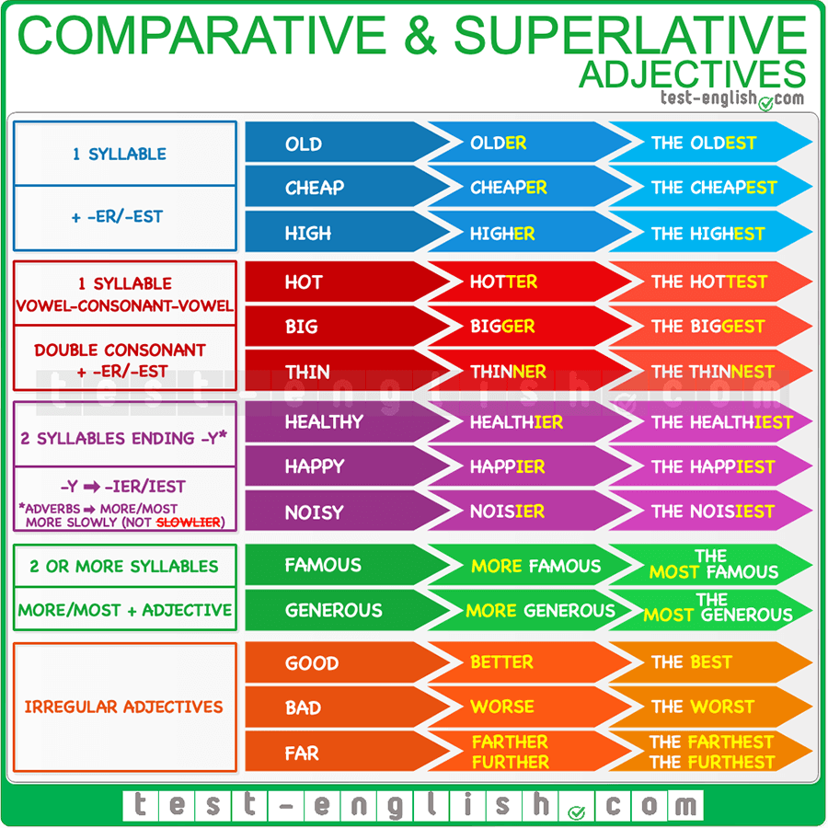

2- Complete the gaps with comparative or superlative adjectives:

- I think she is still ill. She looks even ___________than last week. (bad)
- His results are not __________his colleague's. (good)
- Which of the three supermarkets do you think has _________ range of products? (wide)
- He has _________ potential than anyone thought.(big)
- It's becoming _____________to attract new customers. What we need is a new strategy. (hard)
- ______________ I’ve ever driven is from Curitiba to São Paulo. ( far)
- Things are better organised now – we have __________problems than before. ( few)
- There are more accidents on this road because it's _________ than the others. (narrow)
- I chose this car as my favourite because it's _________ of all the ones I have driven. ( fast)
- She's _____________ in the new job than she was in the previous one. ( happy)

Answer :
- worse
- as good as
- the widest
- bigger
- harder
- The furthest
- fewer
- narrower
- the fastest
- happier

3- Circle the correct form : comparative or superlative
1- This is more expensive / the most expensive book in the whole store.
2- That shirt is dirtier/ the most dirty than the other one.
3- Peter was laughing hard, but his wife was laughing even the hardest / harder!
4- He is strong / the strongest man that I know.
5- Robert is never on time. He always arrives later / the latest than the rest of us.
6- That is better / the best song I've ever heard!
7- Your cat is smaller / the smallest than ours.
8- I thought this test would be difficult, but it's the easiest / easier test I've ever taken.
9- Out of all the films I've seen, this one is sadder /the saddest.
10- Your answer is wrong, but it's the most correct / more correct than the other
students' answers.

Answer:
  - the most expensive
  - dirtier
  - harder
  - the strongest
  - later
  - the best
  - smaller
  - the easiest
  - the saddest
  - more correct

4- Comparative of Equality:
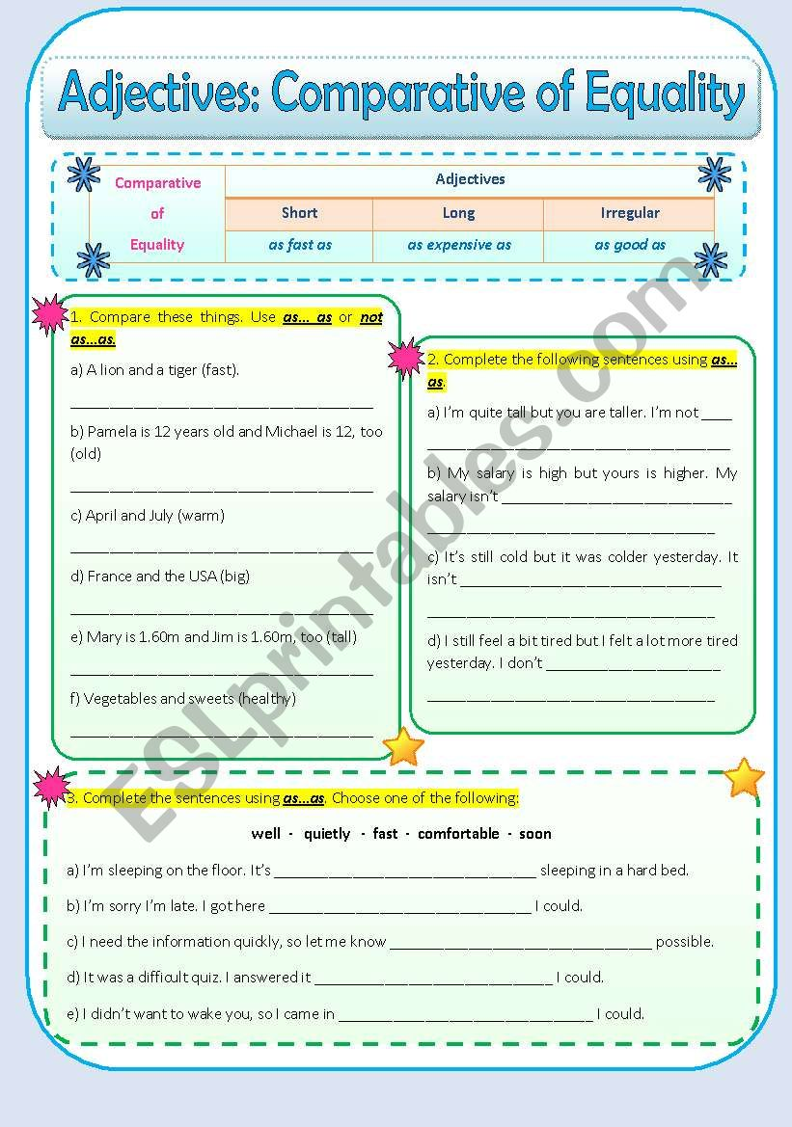

Answer:
Exercise 1
a-A lion is as fast as a tiger.
b- Pamela is as old as Michael.
c- July isn’t as warm as April.
d- France isn’t as big as the USA
e- Mary is as tall as Jim
f- Sweets aren’t as healthy as vegetables.
Exercise 2
- …. as tall as you (or you are).
- …. as high as yours ( or your salary).
- …. as cold as yesterday.
- …. Feel as tired as yesterday.
Exercise 3
- … as comfortable as ….
- … as fast as ……
- … as soon as ….
- … as well as ….
- … as quietly as …

