INGLÊS - ELEMENTARY III (Activities week 4 – June 2020)
_______________________________________________________________________

Learn/Practice English with MOVIES (Lesson #11) Title: Spiderman

https://www.youtube.com/watch?v=Sied-EhCHYc

3 tips for English learners
https://www.youtube.com/watch?v=SaNlHNebLsw
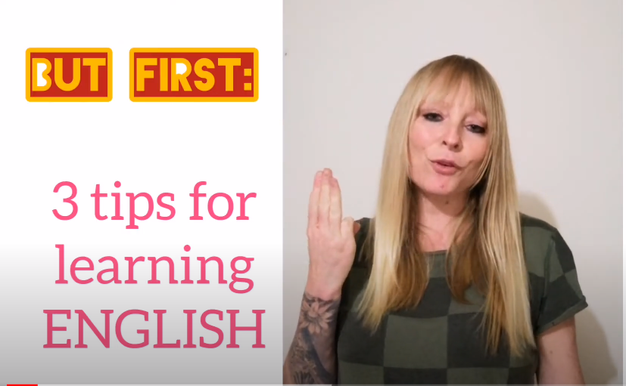

_____________________________________________________________________
Reading Comprehension
https://www.inglesonline.com.br/2008/12/12/compreensao-de-texto-eating-habits/
Tammy is a college student. Here, she talks about her eating habits:
For breakfast, I usually have cereal and milk and a piece of fruit – an apple or a banana. If I wake up really hungry then I’ll also have a piece of bread with jam on it. Sometimes I’ll have eggs, an omelet with cheese and maybe ham. And if I’m late for class, I’ll just have a cup of coffee.
I don’t have a lot of time in between classes this semester, so for lunch I will typically grab something quick to eat, like a slice of pizza. Or a sandwich, either turkey or bacon with lettuce and tomatoes. Despite the junk food at lunch time, I try to keep healthy by having another piece of fruit or a granola bar for a snack in the middle of the afternoon.
Dinner is my favorite meal, and it’s usually when I eat the most. I love pasta, so I’ll often have ravioli or lasagna. Once in a while I will eat chicken with a side of potatoes or spinach. I always have ice-cream after dinner. Chocolate or vanilla, these are my favorites.

Vocabulary:
grab something quick to eat = comer uma coisa rápida
I try to keep healthy = tento me manter saudável
once in a while = de vez em quando
a side of (something) = uma porção de (alguma coisa) acompanhando o prato principal
1-Mark the true sentence:

Tammy never eats fruit.
Her favorite meal is lunch.
She loves vanilla ice-cream.
Tammy has plenty of time for lunch.

2-Complete with an expression from the text:
Tammy tries to compensate for all the .................. ................... she has at lunch time by eating a granola bar or a piece of fruit.

3-Mark the false sentence:

Tammy usually skips dinner.
Sometimes Tammy has eggs in the morning.
When she's late for class, Tammy simply has a cup of coffee.
She loves ice-cream.

4-Choose the best option to complete the sentence:
Tammy usually has ………….. for breakfast and she often eats ………. for dinner.

cereal and milk / pizza
a granola bar / chicken
eggs / ice-cream
a piece of fruit / pasta

5-Mark the true sentence according to the text:

Tammy never eats vegetables.
She usually has lunch at home.
Granola bars and fruit are examples of healthy food.
Tammy has ice-cream in the morning.

Answers:
1-She loves vanilla ice-cream.
2-junk food.
3-Tammy usually skips dinner.
4-cereal and milk/pizza
5-granola bars and fruit are examples of healthy food.

From: www.inglesonline.com.br
______________________________________________________________________

LISTENING AND UNDERSTANDING
CLICK ON THE FOLLOWING LINK AND DO THE EXERCISES:
https://learnenglishteens.britishcouncil.org/sites/teens/files/who_to_invite_-_exercises.pdf
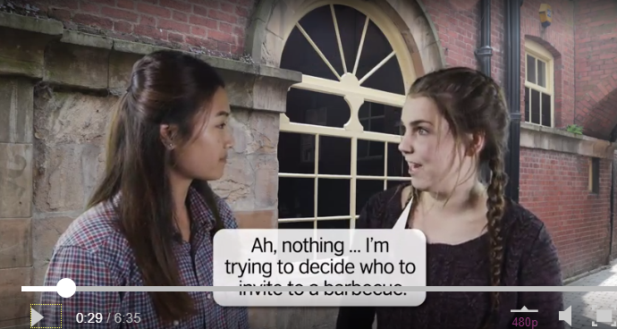
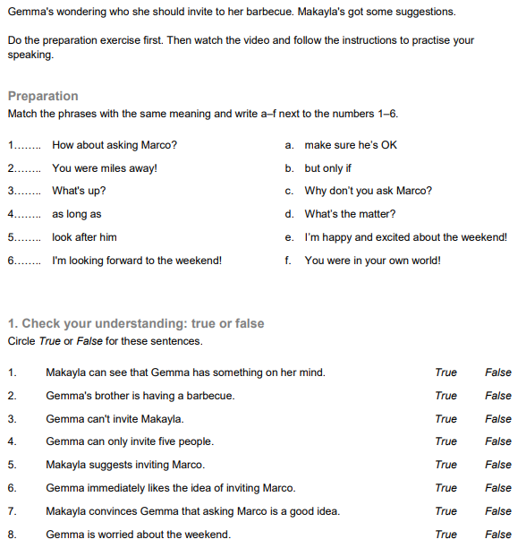
KEY:
Preparation: 1-C 2-F 3-D 4-B 5-A 6-E

Check your understanding:
1-true 2-false 3-false 4-true 5-true 6-false 7-true 8-false
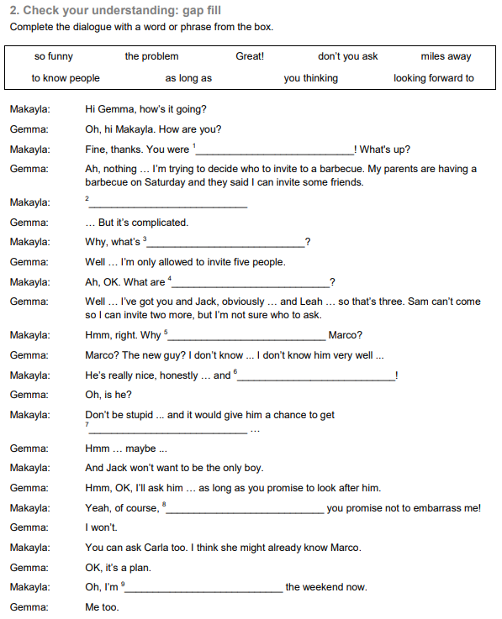
KEY:
1-miles away 2-great 3-the problem 4-you thinking 5-don’t you ask 6-so funny 7-to know people 8-as long as 9- looking foward to
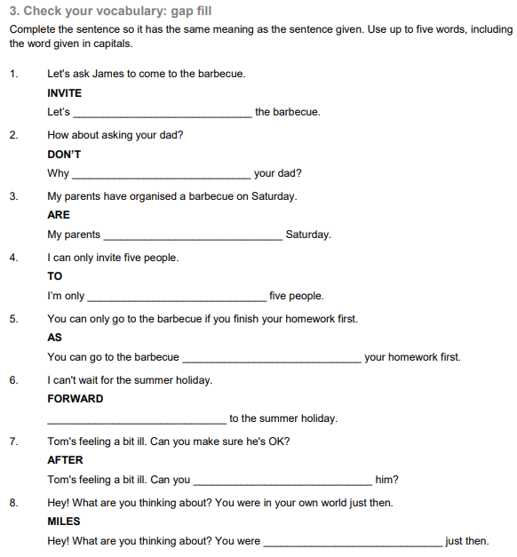
KEY:
- Let’s invite James to 2- Don’t you ask 3- are having a barbecue on
4- allowed to invite 5- as long as you finish 6- I’m looking foward to
7- look after 8- miles away
COMPLETE THE DIALOGUE:

kayla: Hi Gemma, how’s i__ g____?
Gemma: Oh, hi Makayla. How are you?
Makayla: F___, t_____. You were miles away! What’s u__?
Gemma: Ah, nothing … I’m trying to decide who to invite to a barbecue.
Makayla: Oooh ... a barbecue. Am I i______?
Gemma: Yeah, of course! My parents are having a barbecue on Saturday and they’ve said I can invite some friends.
Makayla: Great!
Gemma: … But it’s complicated.
Makayla: Why, what’s t__ p______?
Gemma: Well … I’m only allowed to invite five people.
Makayla: Ah, OK. What a__ you t_______? Who’s on your list?
Gemma: Well … I’ve got you and Jack, obviously … and Leah … so that’s three. Sam can’t come so I can invite two more, but I’m not sure who to ask.
Makayla: Hmm, right. W__ d___ y__ ask Marco?
Gemma: Marco? The new guy? I don’t know ... I don’t know him very well ...
Makayla: Oh, he’s r_____ nice, honestly … and s__ funny!
Gemma: Oh, is he?
Makayla: Don’t be stupid ... and it would g___ him a c_____ to get to k___ people ...
Gemma: Hmm … maybe ...
Makayla: And Jack won’t want t__ b__ the only boy.
Gemma: Hmm, OK, I’ll ask him … as long as you promise to look after him.
Makayla: Yeah, of course, a__ l___ a__ you promise not to embarrass me!
Gemma: I won’t.
Makayla: You can ask Carla too. I think she m____ already know Marco.
Gemma: OK, it’s a plan.
Makayla: Oh, I’m l______ f______ t__ the weekend now.
Gemma: Me too.

Check your answers:
Makayla: Hi Gemma, how’s it going?
Gemma: Oh, hi Makayla. How are you?
Makayla: Fine, thanks. You were miles away! What’s up?
Gemma: Ah, nothing … I’m trying to decide who to invite to a barbecue.
Makayla: Oooh ... a barbecue. Am I invited?
Gemma: Yeah, of course! My parents are having a barbecue on Saturday and they said I can invite some friends.
Makayla: Great!
Gemma: … But it’s complicated.
Makayla: Why, what’s the problem?
Gemma: Well … I’m only allowed to invite five people.
Makayla: Ah, OK. What are you thinking? Who’s on your list?
Gemma: Well … I’ve got you and Jack, obviously … and Leah … so that’s three. Sam can’t come so I can invite two more, but I’m not sure who to ask.
Makayla: Hmm, right. Why don’t you ask Marco?
Gemma: Marco? The new guy? I don’t know ... I don’t know him very well ...
Makayla: He’s really nice, honestly … and so funny!
Gemma: Oh, is he?
Makayla: Don’t be stupid ... and it would give him a chance to get to know people ...
Gemma: Hmm … maybe ...
Makayla: And Jack won’t want to be the only boy.
Gemma: Hmm, OK, I’ll ask him … as long as you promise to look after him.
Makayla: Yeah, of course, as long as you promise not to embarrass me!
Gemma: I won’t.
Makayla: You can ask Carla too. I think she might already know Marco.
Gemma: OK, it’s a plan.
Makayla: Oh, I’m looking forward to the weekend now.
Gemma: Me too.

From: www.britishcouncil.org/learnenglishteens
______________________________________________________________________

Kátia Vecchi – kcjvecchi@uem.com

