Teacher Eliane Cavalher S. Rossi – ecsrossi@uem.br

ACTIVITY 29 – ELEM II – LISTENING

I – Listen to Mona receiving a phone call from her friend Sophie. Choose the right alternative:

1. Sophie phones to greet Mona for her…
a) graduation b) new job c) birthday

2. It was last…
a) Sunday b) Saturday c) month

3. Mona had a …
a) bad time b) great time c) terrible time

4. Mona went out with…
a) Ashmed’s friends b) Ashmed and his family c) Ashmed and some friends

5. They went to a restaurant. It was…
a) Arabic b) Greek c) Egyptian

6. After that, they went …
a) to a party b) home c) to a disco club

7. Sophie says that at the weekend she…
a) went to the cinema b) didn’t go out c) did something very special

ACTIVITY 29 – ELEM II – LISTENING - KEY

PAST TENSE – IRREGULAR VERBS

I – Listen to Mona receiving a phone call from her friend Sophie. Choose the right alternative:

1. Sophie phones to greet Mona for her…
a) graduation b) new job c) birthday

2. It was last…
a) Sunday b) Saturday c) month

3. Mona had a …
a) bad time b) great time c) terrible time

4. Mona went out with…
a) Ashmed’s friends b) Ashmed and his family c) Ashmed and some friends

5. They went to a restaurant. It was…
a) Arabic b) Greek c) Egyptian

6. After that, they went …
a) to a party b) home c) to a disco club

7. Sophie says that at the weekend she…
a) went to the cinema b) didn’t go out c) did something very special

ACTIVITY 30 – ELEM II – GRAMMAR- ORAL

Irregular Verbs - Past Tense
Part I
Fold here
YESTERDAY – THIS MORNING | Fold the paper, write these questions in English | After writing, unfold to check the keys  Practice ORALLY. Test yourself or work with a partner.
1. O que você vestiu ontem? |  | 1. What did you WEAR yesterday?  I WORE jeans and ...
2. Quantos e-mails você escreveu e enviou ontem? |  | 2. How many e-mails did you WRITE and SEND yesterday? I WROTE and SENT …
3. Quantos mensagens você recebeu no seu celular? |  | 3. How many messages did you GET on your mobile? I GOT ……..messages
4. Quantas horas você dormiu noite passada? |  | 4. How many hours did you SLEEP last night? I SLEPT ….. hours.
5. A que horas você acordou esta manhã? |  | 5. What time did you WAKE UP this morning ? I WOKE UP at .....
6. Você ou sua mãe fez sua cama? (make) |  | 6. Did you or your mother make your bed? My mother / I / the maid* MADE my bed (*a empregada)
7. A que horas você saiu de casa? |  | 7. What time did you LEAVE home? I LEFT home at …
8. O que você comeu de manha? |  | 8. What did you eat this morning?  I ATE (bread, cookies, a sandwich-nothing)
9. Quantos copos de água você bebeu esta manhã? |  | 9. How many glasses of water did you DRINK this morning ?  I DRANK …… glasses of water.
10. Você veio para o ILG a pé, de ônibus ou de carro? |  | 10. Did you COME to ILG on foot, by bus or by car? I CAME to ILG …

ACTIVITY 31 – ELEM II – GRAMMAR- ORAL

Irregular Verbs – Past Tense
Part II

LAST HOLIDAY-TRIP | Fold the paper, write these questions in English | After writing, unfold to check the keys  Practice ORALLY. Test yourself or work with a partner.
1. Onde você foi e com quem? |  | 1. Where did you GO and who with? I WENT to …… with my …
2. Quanto tempo você ficou lá? |  | 2. How long did you STAY there?  I STAYED there for …. days
3. Você chegou lá de carro, de ônibus ou de avião? |  | 3. Did you GET there by car, by bus ou by plane? I GOT there by ….
4. Que lugares você conheceu? |  | 4. What places did you KNOW?  I KNEW .. X – X beach…,
5. Quem você conheceu? Alguém interessante? |  | 5. Who did you MEET? Anybody interesting? I MET a boy/ a girl.... I didn’t meet anybody.
6. O que você comprou? Quanto dinheiro você gastou? |  | 6. What did you BUY? How much money did you SPEND?  I BOUGHT …..I SPENT
7. Você pagou em dinheiro ou com cartão de crédito? |  | 7. Did you PAY in cash or by credit card? I PAID …..
8. Como você se sentiu lá? Feliz, triste? |  | 8. How did you FEEL there? Happy, sad? I FELT …..
9. A que horas você podia acordar? |  | 9. What time COULD you wake up? I could wake up at 10, 11 o´clock…
10. Você viu algum filme lá? Qual filme? |  | 10. Did you SEE any films there? What film?  I SAW …

ACTIVITY 32 – ELEM II – LISTENING

PRICES

I – Listen to a man ordering a snack in a coffee shop and choose the right alternative.

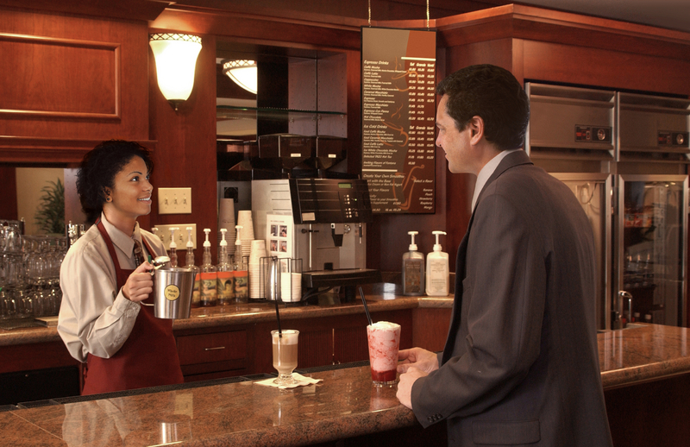

1. He goes to a coffee shop:
a) at noon
b) in the afternoon
c) at breakfast time

2. He orders:
a) a milk shake and a sandwich
b) 8 sandwiches
c) a steak sandwich

3. To drink he orders:
a) a regular apple juice
b) a large apple juice
c) a large orange juice

4. The price ($$) of his snack is:
a) £ 7,12
b) £ 17,20
c) £ 7,20

II – Listen to 4 dialogues. Circle the correct price:

- He changes US$ 140 into pounds (£). That is… 1. £ 7 2. £ 17 3. £ 70
- He buys a dictionary. It costs… 1. £ 9 2. £ 19 3. £ 90
- The taxi ride to the city centre costs … 1. £ 4 2. £ 14 3. £ 40
- How much are 2 cokes? 1. £ 5.08 2. £ 5.18 3. £ 5.80

ACTIVITY 32 – ELEM II – LISTENING - KEY

PRICES

I – Listen to a man ordering a snack in a coffee shop and choose the right alternative.

1. He goes to a coffee shop:
a) at noon
b) in the afternoon
c) at breakfast time

2. He orders:
a) a milk shake and a sandwich
b) 8 sandwiches
c) a steak sandwich

3. To drink he orders:
a) a regular apple juice
b) a large apple juice
c) a large orange juice

4. The price ($$) of his snack is:
a) £ 7,12
b) £ 17,20
c) £ 7,20

II – Listen to 4 dialogues. Circle the correct price:

- He changes US$ 140 into pounds (£). That is… 1. £ 7 2. £ 17 3. £ 70
- He buys a dictionary. It costs… 1. £ 9 2. £ 19 3. £ 90
- The taxi ride to the city centre costs … 1. £ 4 2. £ 14 3. £ 40
- How much are 2 cokes? 1. £ 5.08 2. £ 5.18 3. £ 5.80

